**SMARTBRIDGE IN COLLABORATION WITH IBM**

 

**A PROJECT ON**

**PREDICTING ENERGY OUTPUT OF A WIND TURBINE WITH MACHINE LEARNING**

SUBMITTED IN FULFILMENT FOR THE COMPLETION OF

THE PROJECT

Submitted by

MAARKA AKHILA

SUNKARA CHANDANA

THALLA AKANKSHA

**INTRODUCTION**

**A.OVERVIEW**

Wind energy is the use of wind to provide the mechanical power through wind turbines to turn electrical generators and traditionally to do other works like milling or pumping. Wind power is a [sustainable](https://en.wikipedia.org/wiki/Sustainable_energy) and [renewable energy](https://en.wikipedia.org/wiki/Renewable_energy), and has a much smaller [impact on the environment](https://en.wikipedia.org/wiki/Environmental_impact_of_wind_power) compared to burning [fossil fuels](https://en.wikipedia.org/wiki/Fossil_fuel). [Wind farms](https://en.wikipedia.org/wiki/Wind_farm) consist of many individual wind turbines, which are connected to the [electric power transmission](https://en.wikipedia.org/wiki/Electric_power_transmission) network.

This project is aimed at predicting the energy output of a wind turbine using Machine Learning algorithms. The energy output of a wind turbine depends largely on the weather conditions of the wind field. With the wind speed, wind direction, etc. the energy output also changes. In this project we build a machine learning model using regression algorithm. The model is trained with the historical data of wind turbine energy output and this data is used for predicting the energy output of the wind turbine latter.

Thus, this project predicts the energy output of the wind turbine, so energy suppliers can coordinate the collaborative production of different energy sources more efficiently to avoid costly overproduction.

**B.PURPOSE**

The main purpose of this project is to predict the energy output of a wind turbine using Machine Learning. The energy of the wind turbine depends of various factors like wind direction, wind speed, weather conditions and other factors. Considering these various factors, we designed a project to predict the energy output of the wind turbine.

**LITERATURE SURVEY**

**EXISTING PROBLEM**

The output energy prediction of wind turbine is difficult because the weather conditions, wind speed and other factors are not stable, they change time to time. Hence it may be difficult to predict the output energy.

**PROPOSED SOLUTION**

To overcome the above stated problem, we designed a project “Predicting the energy of the wind turbine using Machine Learning”. This project considers all the factors like weather conditions, speed of the wind, direction of the wind flow and predicts the output energy.

This project is designed with the help of IBM cloud platform, Node-Red, Watson Studio. The data set is collected from kaggle.com. Considering all the required factors, the output of the wind is predicted accurately.

**THEORETICAL ANALYSIS**

**A.BLOCK DIAGRAM**



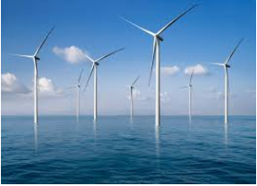     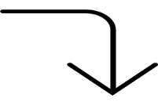

Collecting data from Publishing data to IBM Sending data to the project

sensors on field Cloud using Raspberry Pi in Watson Studio

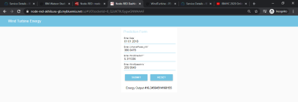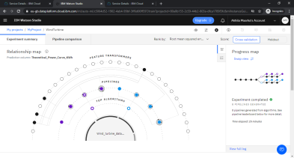

User Interface Build a User Interface Conduct an Auto AI experiment

Using Node-Red flow with the data collected



**B. SOFTWARE DESINGING**

Firstly, we have assigned tasks to different team members as a part of the project planning. The requirements include:

* IBM Cloud Account
* Node-Red
* Watson Studio
* Data set for the project

Secondly we collected the wind turbine data set from <https://www.kaggle.com/berkerisen/wind-turbine-scada-dataset>. It is in “.csv” format.

Then, we created an IBM Cloud account at cloud.ibm.com. Next we created an IBM Watson Studio project with the name “MyProject”. In that project we added our wind turbine data set.

Latter, we created an Auto AI experiment with the name “WindTurbine” and performed the experiment. In the results of the experiment, we saved the best algorithm; “Random Forest Regressor” as a model with the name “WindTurbine - P3 RandomForestRegressorEstimator” and as a notebook named “WindTurbine - P3 sdk notebook”.

Finally, to give this model to the user, we developed a user interface using Node-RED by building a node-RED flow.

**EXPERIMENTAL INVESTIGATION**

The output is seen when the required values like date, LV active power (KW), wind speed (m/sec) and wind direction. The predicted energy output of the wind turbine is seen on the screen. Thus, we can predict the energy output using this project.

**FLOW CHART**

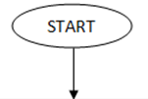

Collect the data set



Create IBM Cloud Account



Create Watson Studio Project



Perform an Auto AI experiment with the wind turbine data



Build User Interface using Node-RED



In the UI enter the inputs: Date, LV Active Power, Wind Speed and Wind Direction



On clicking the “SUBMIT” button predicted energy output is displayed in UI

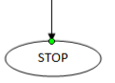

**RESULT**

Considering all the factors we can predict the output energy of the wind turbine. The factors we considered here are date, LV active power in kilo watts, speed of the wind in meters/seconds and the direction of the wind. After entering all these factors, the output energy is displayed on the screen.

**ADVANTAGES**

The energy produced by the wind turbines can be used for various domestic and industrial activities. Also, it is clean, safe and a renewable source.

This project makes the prediction of energy output of wind turbine an easy task and by predict the output energy a wind turbine, energy suppliers can coordinate the collaborative production of different energy sources more efficiently to avoid costly overproduction.

**DISADVANTAGES**

The major disadvantage is that in real time usage we require lot of sensors and the cost increases.

**APPLICATIONS**

This project can be implemented in a wind farm to control the energy production of the farm as required and desired under given weather conditions.

**CONCLUSION**

This project predicts the energy output of the wind turbine under different weather conditions and wind behaviors with high accuracy.

**FUTURE SCOPE**

Wind energy is available without any cost and it does not emit any greenhouse gases. This makes it a great source of energy production for any developing state. The field of wind energy has tremendous scope for innovation, translating to real world applications and tremendous economic opportunity.

**BIBILOGRAPHY**

<https://www.kaggle.com/berkerisen/wind-turbine-scada-dataset>

<https://cloud.ibm.com/login>

<https://en.wikipedia.org/wiki/Wind_power>